# **How to Create Custom Wordpress Theme**

## **Copy Custom Theme from Existing projects**

We have created so many different theme for our wordpress project you can simply copy that and add in your project

Below are the theme list

| Saleshandy (Latest) | Live | https://www.saleshandy.com |
| --- | --- | --- |
| Saleshandy_blog (Latest) | Live | https://www.saleshandy.com/blog |
| scalp | Live | https://www.scalphairtransplants.com/ |
| khadayta | Local | http://192.168.1.200/khadayta/ |
| syncrop | Local | http://192.168.1.200/syncrop/ |
| datazapp | Live | https://www.datazapp.com/ |
| crossshore | Live | https://www.crossshoresolutions.com/ |
| sourcepro | Local | http://192.168.1.200/sourcepro/ |

You can copy any theme from below folder and add in your project

\\server1\Projects\libraries\wordpress\themes

**After copy you need to do following steps**

1. Change the theme folder name
2. Change the theme name from style.css
   1. Open the style.css
   2. Change the Theme Name

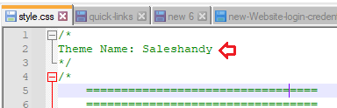

1. Change the screenshot.png to your theme screenshot

Note: File name has to screenshot.png only

## **How to create custom Theme**

It’s actually very simple you can copy any of the wordpress default theme

1. Twentytwenty
2. Twentytwentyone
3. twentynineteen

**Twentytwenty** is a good theme in terms of the predefined component and function. We usually copy that theme and customize it as per the design.

After copy you can follow the same above steps,

1. Change the folder name with your project name
2. Change the Theme name from style.css
3. Change the screenshot.png with your theme design screenshots